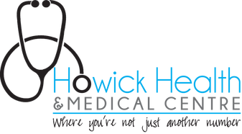

You have an appointment with Dr Vallings on:

You may contact her via one of two methods though Doxy.me is the preferable secure option.

Doxy.me (you do not need to download any software)
Simply go to the link below to access Dr. Valling's virtual waiting room:

https://doxy.me/DrVallings

PLEASE ensure your microphone and audio is working properly prior to the consultation. Have your mobile or landline ready to use in case there are any audio issues.

If you have any issues with either of these 2 items try one of the 2 solutions below:

(a) Click on the camera icon which is to the right of the website address (doxy.me/DrVallings) at the top. Make sure you enable access (continuing allowing….)

(b) At the bottom of the screen select the 3rd icon (settings) and ensure you have the correct microphone and webcam selected

If you are on a smartphone ensure you have the correct browser as suggested by doxy.me (safari for iphones).

Once you have logged onto doxy.me please wait and Dr Vallings will connect to you when she is ready. Please do not send any messages via Doxy.me.

Phone consult
When it is your appointment time please call Dr. Vallings on (this will be emailed to you when you make your appointment). Please ensure you have an up to date landline AND mobile number when you reply to this email. Dr Vallings will call you when she is available to consult and will advise you to call her.

So please email back to us:
1. Your mobile and landline
2. Your preferred method of contact (phone or virtual)

Cost of consultation will be $288.00 (one hour duration) (this is subject to change- please see website for any updates). This can be claimed back from your Insurance Company at GP rates.
If you are on a benefit, WINZ may help with fees as part of your disability allowance. Please notify us if you are unable to keep your appointment as we have a long waiting list. 50% of fee will be charged for a missed appointment or late cancellation (within 24 hours). You may need a follow up appointment and this will be for ½ hour and cost will be $144.00 (updated prices on website).
If you have any questions please email howickreception@outlook.com or call (09) 534 3978.

Kind regards,

RECEPTION at HOWICK HEALTH AND MEDICAL CENTRE

