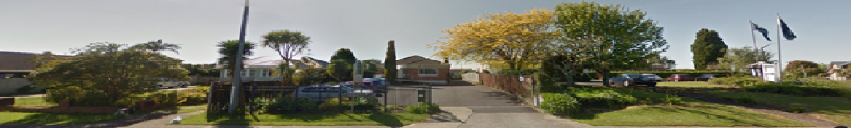

New Patients
Welcome! If you wish to register at our practice, you will need to fill in an enrolment form which can be reached from the ‘Enrolment Form’ button link on the ‘New Patient’s page.
At the first appointment please turn up approximately 15 minutes prior to your stated time so you can fill out medical information form and an email and mobile phone form that will help inform your doctor about your medical history and allow us to communicate with you. Alternatively you can print this out from our website below and fill it in prior to coming in.
If you are not enrolled at our practice then we will not receive funding from the Ministry of Health. You will therefore notice it will be more expensive if you are not enrolled.
Information about your intent to be enrolled as a regular patient will be sent to ProCare and the Ministry of Health to secure subsidies.
This practice transfers information electronically and in printed form, and procedures are in place to ensure information is sent securely to adhere to strict privacy legislation. This notice is to inform you of the information transferred from this practice.

Some Housekeeping Tips
We Would appreciate if you can turn off your cell phone during consultation time.
Unpaid accounts will incur an admin fee if not paid on the day.
If extra time is required (note generally 1 issue per standard 15 minute consult), please indicate this to reception. Note the consultation time is for 15 minutes only. Any additional time spent will be charged for (please note as funding is only for a standard consult, additional ‘unfunded’ rates apply for additional time).
Scripts/Reports/BP checks/Materials used/Time spent with the nurse will incur a charge –more information is displayed at the front desk and on the fees section. If you are due for a review (this is at the nurses’ and doctors’ discretion though generally every 6 months) you will be asked to come in.
After Hours –advice can be obtained by calling our number 534 3978 (you will be directed to a triage health professional) or you can call the local A&E Centre (EastCare 260 Botany Rd 2771516 Ti Rakau A&E 316 Ti Rakau Dve 273 8980).
We have a zero tolerance to disrespectful behaviour to any of our staff members and our patients. We reserve the right to revoke your right to enrol with Howick Health and Medical Centre.

