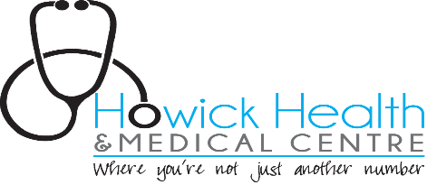

Level lockdown instructions

Level 1 lockdown
We will keep patients who have cold symptoms away from our well patients so please understand if you are told you are not allowed to come into the practice. We have not had a positive case at our practice yet (fingers crossed). We would encourage you to wear a mask when entering our practice. If you have cold symptoms DO NOT ENTER our practice and call us instead please.

Level 2 lockdown
This means COVID-19 is in the community. While we are seeing more patients in person in level 2 we are still offering phone and video consultations. All in person consultations will be preceded by a phone discussion (triage) by the doctor so please stay in your car and call us upon arrival. We would encourage you to wear a mask when entering the practice. If you have any cold symptoms please DO NOT enter our practice.

Level 3 lockdown
It is recommended that we move more to remote (virtual -video or phone) consultations. The doors will be locked and you will be required to call us prior to entering. Please wear a mask. We are encouraging virtual consultations (phone or video) in about 70% of cases so it is possible you may not see the doctor even if you booked an in person consult and arrive at the practice. If you have a virtual consult and have photos of a skin lesion/rash/ sore throat etc please send this at least 30 mins prior to your appointment to howickreception@outlook.com. We appreciate your understanding in what is a challenging situation for all.

Level 4 lockdown
Much the same as level 3 except a greater proportion of visits will be virtual.

Unvaccinated patients
We have a duty of care to you, our practice staff and other patients. Therefore you will be encouraged to have a virtual consultation in the first instance if appropriate -you can still arrive in your car but please do not come in but call us first. If an in-person consultation is deemed necessary you will either be seen in your car or the cabin.

