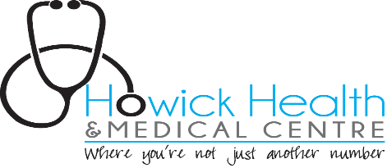
Patient Portal Consent Form

When signing up for the use of the patient portal ConnectMed for the purpose of accessing your own health information please read the following. The portal can be a valuable communication tool, but has certain risks. In order to manage these risks we need to impose some conditions of participation.
You are responsible when viewing your information to maintain the confidentiality of this information. This requires up to date antiviral software on your electronic device you choose to access the information on. Always remember to log out and close your browser when you have finished accessing the password protected patient portal services. YOU SHOULD NEVER USE A PUBLIC COMPUTER TO ACCESS THE PATIENT PORTAL.
If you allow a family member to access your confidential health records and that family member requires further clarification of a message or result, it is your responsibility to convey this information due to the strict privacy rules our practice adheres to (Privacy Act 1993).
If you have many questions about your results we encourage you to make an appointment with your doctor. Any urgent queries regarding your health information should not be communicated via the patient portal. A phone call or appointment would ensure your query is attended to promptly or call 111 in an emergency.
Online appointment bookings that have not been confirmed by an email are deemed unsuccessful. Please call our practice if this occurs.
Charges apply for online prescriptions as per prices seen when you are ordering a script. Future charges may also apply for medical advice when messaging is enabled on the patient portal.
Please allow at least 1 working day for the nurse to attend to your requested script. So if you request your script on a work day Friday afternoon prior to a long weekend, we will not have the script ready until the following Wednesday morning.
Any questions regarding lost passwords should be directed to ConnectMed (please see their website www.connectmed.co.nz).
It is imperative that you update our centre with any changes in your contact details especially your mobile number and email address. This will ensure your continuing access of the portal.
We have the right if we suspect unconsented access to your patient portal or abuse has occurred, to restrict your access and contact you about the unauthorised access or abuse.
You agree not to hold Howick Health and Medical Centre and any of its staff liable for network infractions beyond their control.

I acknowledge that I have read and fully understand this consent form. I have been informed about the potential risks of the Patient Portal and agree that I understand the risks associated with online communications between my doctor and myself, and consent to the conditions outlined herein. I acknowledge that using the Patient Portal is entirely voluntary and I agree to adhere to the policies set forth herein, as well as any other instructions or guidelines that my doctor may impose for online communications. A breach in the contract may result in restricted/declined access to the portal. I have been given an opportunity to ask questions related to this agreement and all of my questions have been answered to my satisfaction.

Patient name: ……………………………………………………………………………………………………….

Patient Signature: ………………………………………………………………………………………………….

Date: ………………………………………………………………..

Any change in following information? Please add below.
- Address:
- Mobile number:
- Home or work number: (hm) ………………………………(wk)………………………….
- Email address:
- Next of kin:
NEXT STEPS
Register with connectmed.co.nz (essential). You are already registered if you are able to make appointments online now.
Once this form is completed you can send this to us in the following manner:
- Email a copy of this form to howickreception@outlook.com or
- Post to 108 Ridge Rd, Howick, Auckland 2014 or
- Fax to (09) 537 3672 or
- Simply bring this in person to the medical centre.
Please wait for 7 working days for account to be enabled

