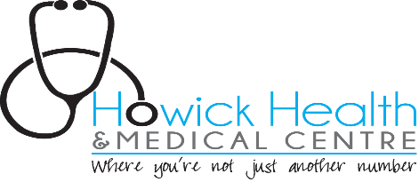

Travel COVID swabs

We do pre-departure COVID swab tests
The cost is $220 and payment is required prior to testing. Additional fee applies for non standard paperwork.
Please note it can take two, sometimes three days (in the event of a community COVID-19 outbreak) to receive the result. Turnaround time for results can be improved if samples are sent directly to the laboratory (e.g. you can take the sample yourself) to Labtests, Specimen Services, 37-41 Carbine Rd, Mt Wellington. There is a door on the side of the building, knock on this door and state the COVID swab is to be processed as a pre-departure swab. This option is available Monday to Saturday from 9am to 4pm (shortened during level 3 and 4 lockdown -please check with Labtest).

More details regarding transportation of the swab and time frames can be seen here at this link:
https://www.labtests.co.nz/commercial-services/pre-departure-covid-19-test/

For Casual patients ‘COVID travel swabs’
Please email to howickreception@outlook.com answers to the following:

Full Name:
DOB:
Home address:
Mob no:
Gender:
NHI no (if you know this):

Once we have received this via email we can arrange for a COVID swab to be done on the day with the nurse. Please call reception 1 hour after sending the email to arrange an appointment for a COVID swab with the nurse.

